1.Open the command prompt and use the ipconfig tool to find your computer's IPv4 address and default gateway, then take a screenshot of the output.
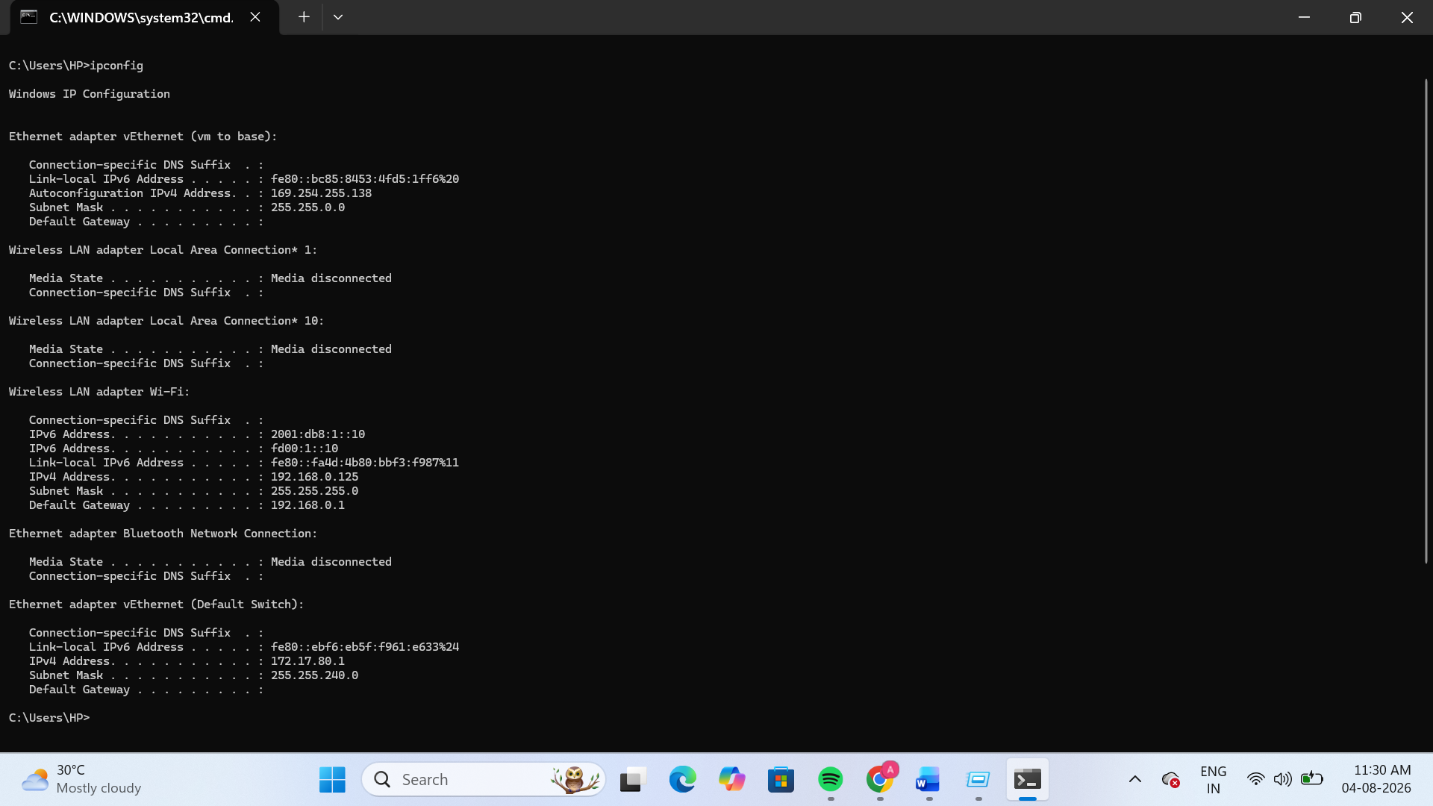
2.Use the ping command to check the connectivity between your computer and www.google.com, then note down the average response time shown.
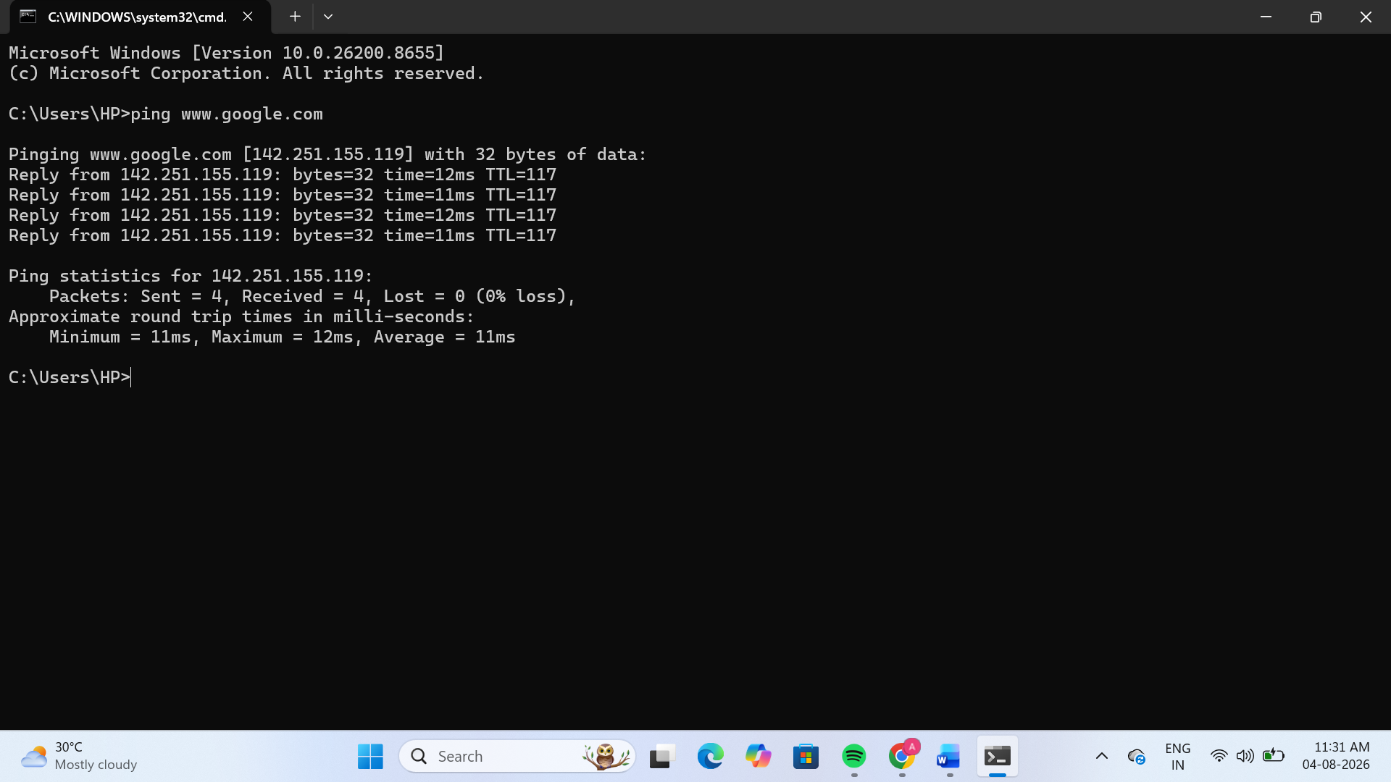
3.Run the tracert (or traceroute on Linux/Mac) command to www.flipkart.com and list the number of hops it takes to reach the destination.
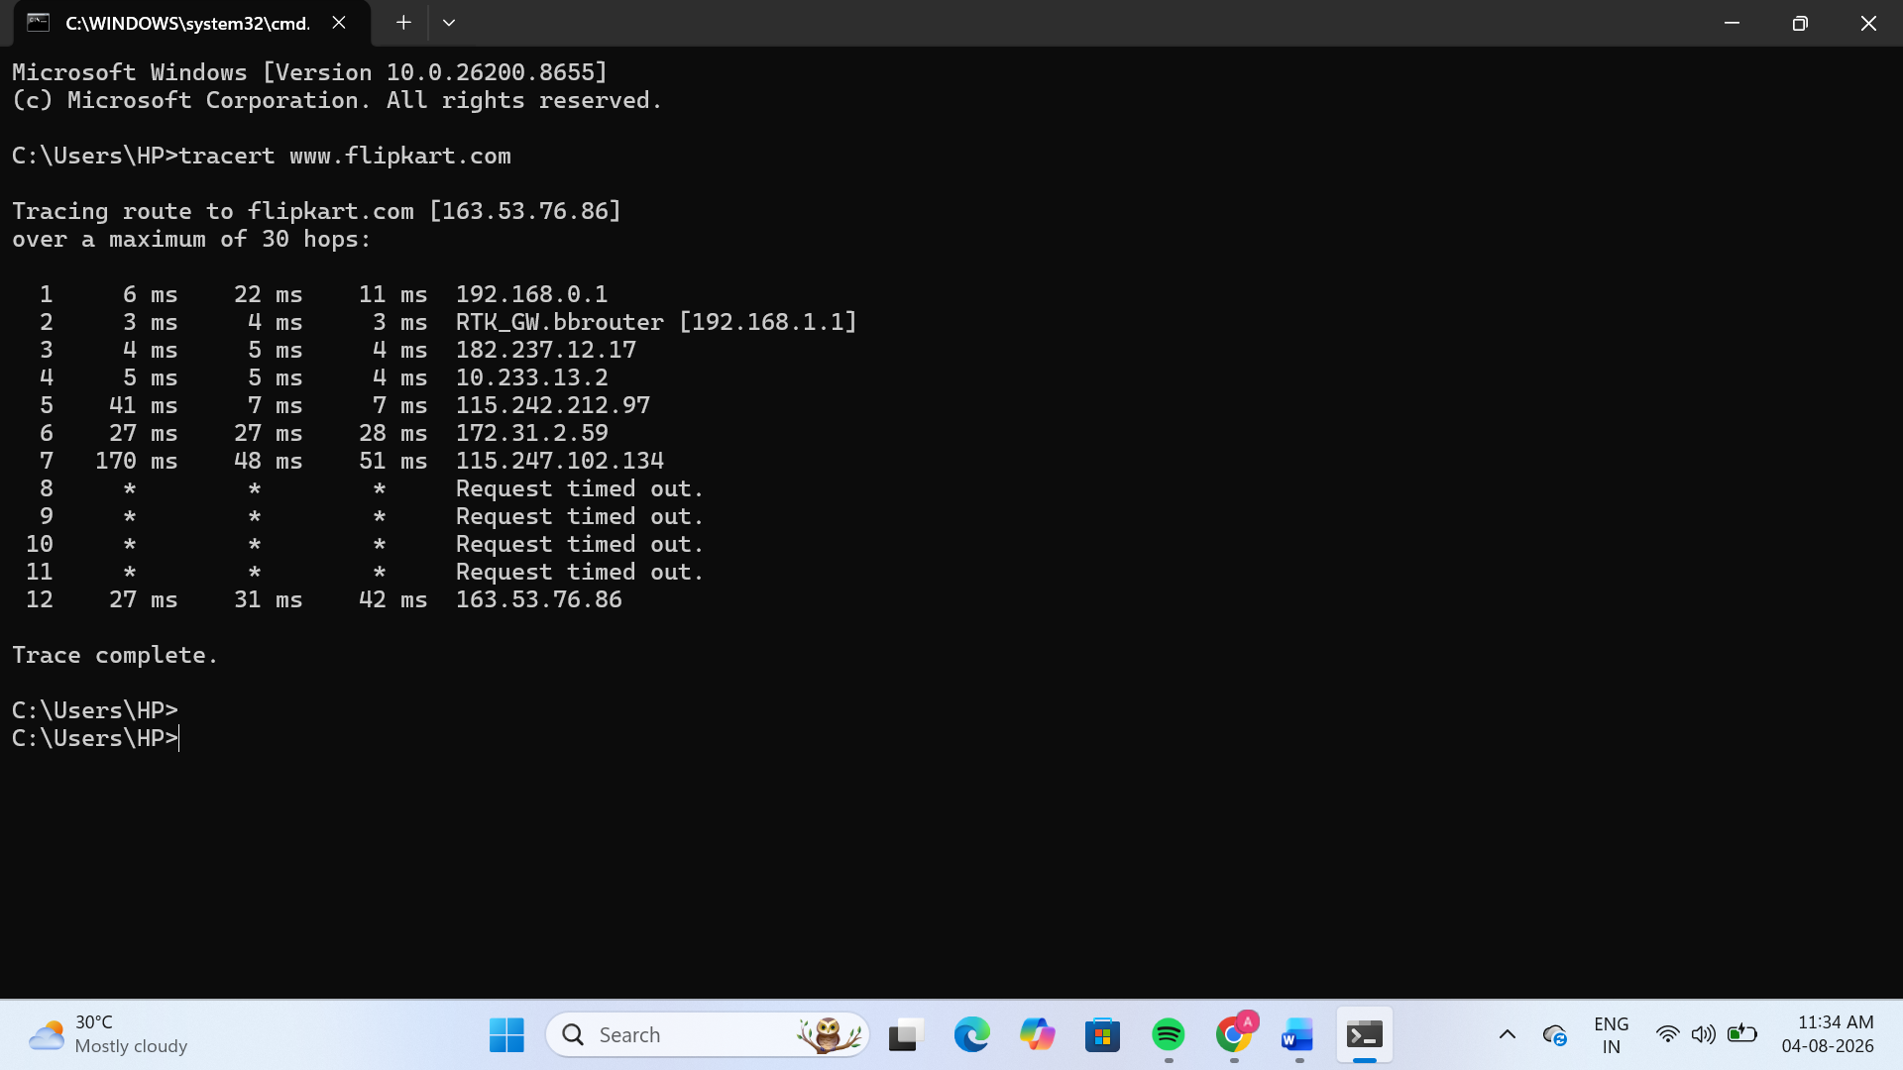
4.Use the nslookup tool to find the IP address of www.spotify.com and explain in one line what this tool helps you verify.
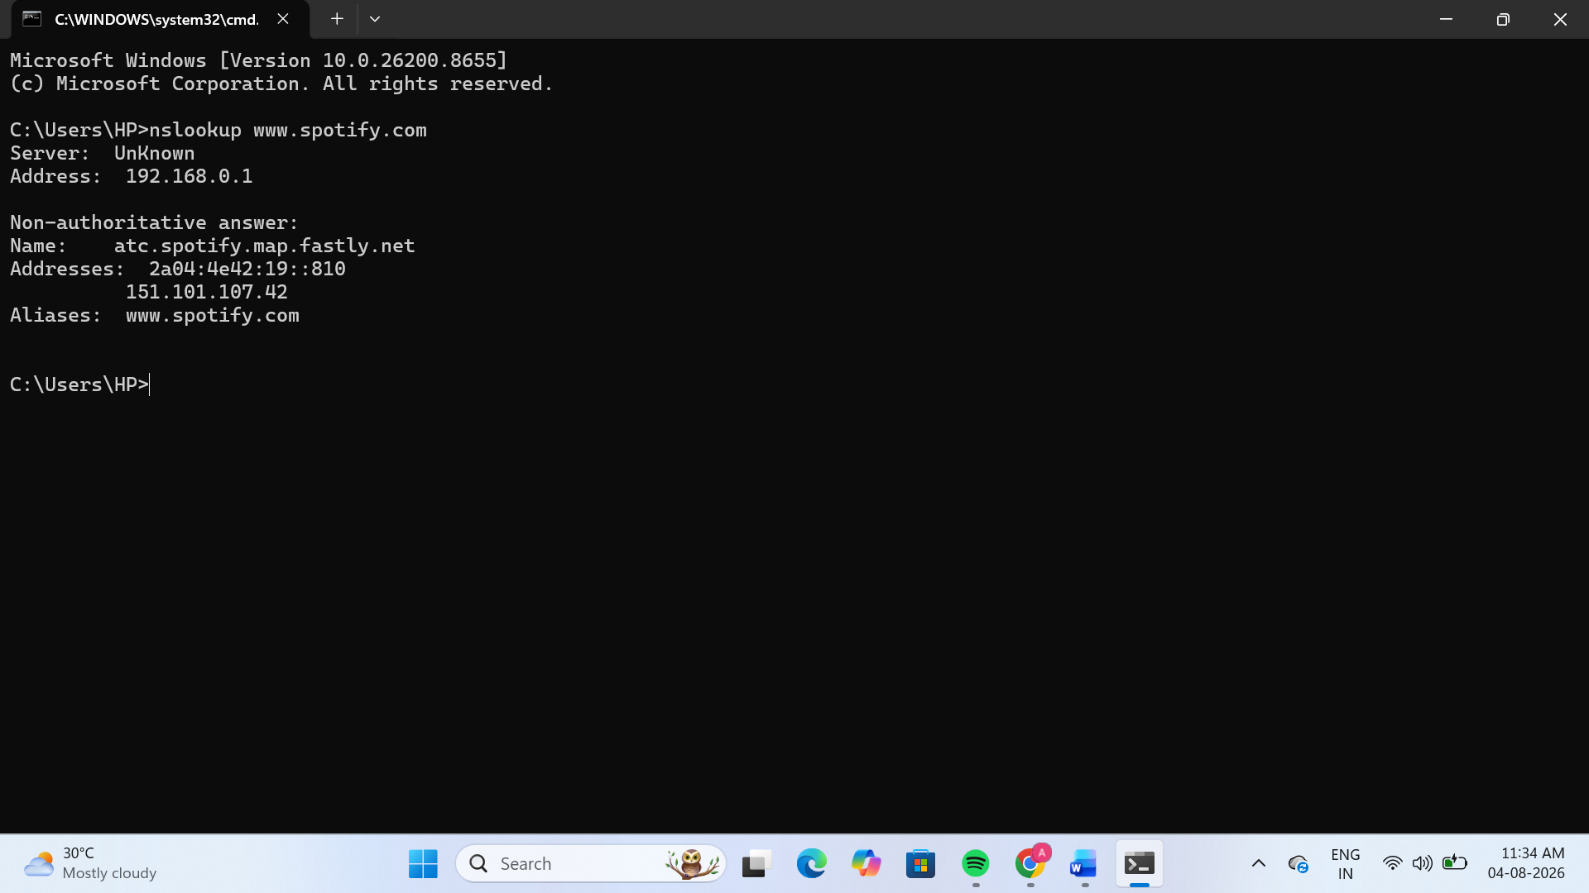
- IP Address of www.spotify.com:
- 151.101.107.42
->The nslookup tool helps verify the IP address associated with a domain name and checks whether DNS is resolving the domain correctly.
5.A friend says they cannot access Zomato’s website from their laptop. Suggest a sequence of three troubleshooting commands (choose from: ping, ipconfig, tracert, nslookup) you would run to diagnose the issue, and briefly state what each command would help you check.<br><br><em><strong>Hint:</strong> Think about checking both network connectivity and DNS resolution.</em>
Command | What it checks
ipconfig | Checks whether the laptop has a valid IP address and default gateway.
nslookup www.zomato.com | Checks whether the DNS server can correctly resolve the Zomato domain name to an IP address.
ping www.zomato.com | Checks whether the laptop can reach the Zomato server and confirms basic network connectivity.

Alternative (if ping fails):
- tracert www.zomato.com – Shows the path packets take to the website and helps identify where the connection is failing.

